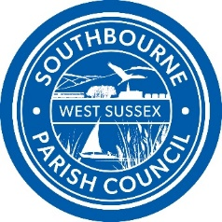
Southbourne Parish Council
The Village Hall
First Avenue, Southbourne
PO10 8HN
Telephone (01243) 373667

Sheila Hodgson
clerk@southbourne-pc.gov.uk www.southbourne-pc.gov.uk
__________________________________________________________________________

Dear Sir or Madam,

I hereby give you notice that the Annual Parish Electors Meeting for the Parish of Southbourne will take place at 6.30pm on Thursday 9th May 2024 at St John’s Church Centre, Main Road, Southbourne PO10 8JE

The Meeting is primarily intended for persons registered as local government electors for the Parish of Southbourne. However, all members of the Public and Press welcome to attend. Any matters affecting the Parish may be discussed. Only persons registered as local government electors for the Parish of Southbourne are entitled to vote at the Meeting.

If you wish to present a report or resolution, please inform the Clerk to the Council, by the 3rd May 2024 clerk@southbourne-pc.gov.uk
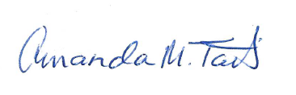


Cllr. Amanda Tait Sheila Hodgson
Chairman Southbourne Parish Council Parish Clerk

26th April 2024
AGENDA

- Welcome by the Chair and introduction of Councillors present

- To approve and sign the Minutes of the Parish Meeting of Electors held on Friday 19th May 2023

- To receive the Annual Report of the Council

- To receive the Accounts of the Parish Council year ending 31st March 2024 and Budget for 2024-2025

- To consider any Resolutions of which written notice has been given by Friday 3rd May 2024

- To welcome the Chichester District Council’s Divisional Manager for Communities who will give an overview of the role, information regarding the recruitment for a new Gypsy Traveller role and CDC’s response to unauthorised encampments and to further welcome the Community Safety & Community Engagement Officer to offer advice on safety

- To welcome PCSO’s James Ryder to give an overview of his role withing the Parish

- Open Forum including questions to Councillors and Attendees

