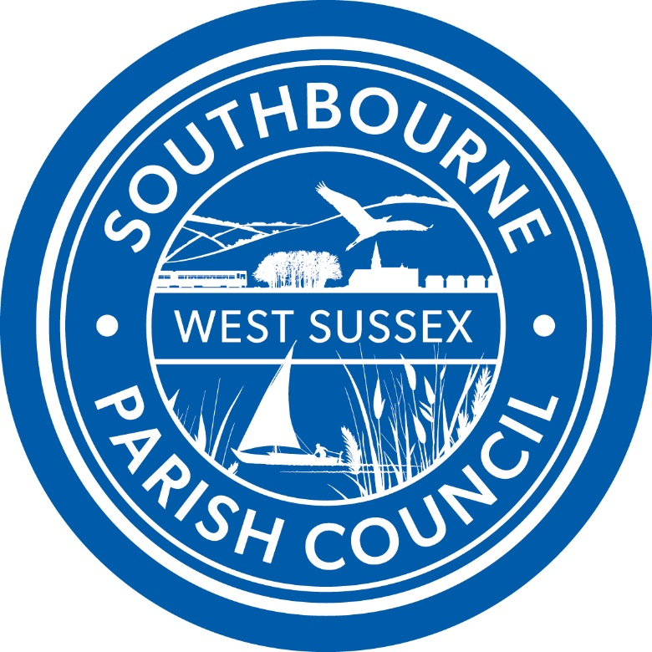

SOUTHBOURNE PARISH COUNCIL

BIODIVERSITY POLICY

ADOPTED February 2024

SOUTHBOURNE PARISH COUNCIL
Biodiversity Policy

Background
Under the Natural Environment and Rural Communities Act 2006 there is a duty on public authorities in England, including Parish Councils, to have regard to conserving biodiversity as part of their policy or decision making. This was further strengthened by the Environment Act 2021 so public authorities must now consider what they can do to conserve and enhance biodiversity in England. This means a public authority must:
- Consider what they can do to conserve and enhance biodiversity.
- Agree policies and specific objectives based on their consideration.
- Act to deliver policies and achieve objectives.

Biodiversity refers to the variety of life on earth¹.

The Local Area
The parish of Southbourne is located at the western edge of Chichester District within
West Sussex, extending from Chichester Harbour in the south to the A27 road at its northern boundary. The harbour is a designated Area of Outstanding Natural Beauty (AONB) and presents long distance views of the South Downs National Park (SDNP).
It contains the settlements of Hermitage, Lumley, Nutbourne West, Prinsted, Southbourne and Thornham.

The parish provides a range of services and contains a number of facilities that reflect
its size and location, including a library, village hall, infant, junior and secondary schools, leisure centre.

Links to other locations via public transport from the parish are reasonable, with the
main Brighton to Portsmouth railway line running east-west. Trains stopping at Southbourne and Nutbourne stations provide connections to Chichester, Littlehampton and Bognor to the east, and also run west to Havant, Portsmouth and Southampton.

Parish Council responsibilities
The Parish Council owns and maintains the recreation ground which incorporates a children’s playground, adult outside gym equipment, football playing fields and sports pavilion.

The Parish Councils is responsible for the protection and maintenance of land by the foreshore at Prinsted as gifted to them under the Open Spaces Act of 1906

The Parish Council is also responsible for the provision and updating of the Southbourne Neighbourhood Development Plan, of which the key objectives are:
- A Strong Integrated Community that all residents will feel part of and be proud of
- A Great Place to Live and Work
- Sensitively planned with our Landscape & Heritage Protected and Celebrated
- A Settlement that sits comfortable and sustainably in its Sussex landscape applauded for its protection and management of its environment’s assets, its promotion of Health & Wellbeing of residents, including its visionary Green Ring and for its status as a haven for nature and Wildlife.
- Adapted and prepared for climate change and zero carbon living

What the Parish Council will do
- Consider the impact on biodiversity in the decisions made through the Parish Council, especially when commenting on planning applications.
- It will reduce the use of pesticides and herbicides used on Parish Council owned land.
- It will review how it manages the land it owns within the parish this may include but is not limited to.
  - Leaving standing and fallen dead wood as a habitat for invertebrates
  - Leaving leaf litter and dead vegetation wherever possible as a habitat for invertebrates
  - Removing invasive and non-invasive species that are detrimental to native flora or fauna as required.
- As owner of the playing field the Parish Council will
  - To preserve the trees and encourage biodiversity around the edges of the playing field
  - In partnership with The Southbourne Environment Group maintain the area, known as the Triangle, to either grow as long grass and flowers, or to be formally managed as a wildflower area.
- The Parish Council will look to promote biodiversity via the Parish Council website.

